Name: Sujal Shrestha
Q1. What is the purpose of the main() function in a C program? Explain its significance.
The main() function is an essential entry point for every C program. It is basically a point where the program starts. Its primary purpose is to serve as the initial function called by the operating system when a program is executed. It is where the program's execution begins and ends.
A C-program must have exactly one main() function to be valid and runnable/executable. It acts as the brain of the program. It calls other functions, manages logic and decides when the program should stop. It also tells the operating system whether the program finished correctly or crashed by returning an integer usually 0. The main() function is the starting and ending line of the entire program.
Q2. Explain the difference between a variable declaration and a variable initialization in C.
Variable declaration is the process of defining a variable’s name and data type to the compiler. It informs the compiler about the variable and how it should be interpreted. It typically does not allocate any storage space. It can declare a variable multiple times in the program. For example: int x; float y; etc.
Variable initialization is the process of giving a variable an initial value when it is defined. If a variable is defined but not initialized, its initial value is typically undefined or garbage data unless it is a global variable which defaults to zero. It occurs when a memory is allocated. It can initialize the variable only once when being defined. For example: int x=5; float y=1.5; etc.

Q3. Write a C program to display a personalized greeting message. (Should contain 'hello' or 'welcome' in the message)
#include <stdio.h>
int main() {
printf("Hello everyone!!!");
return 0;
}

Output:
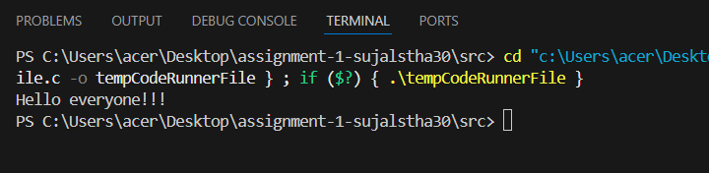
Q4. What are the different data types available in C? Provide examples of each data type.
In C, data types define the type of data a variable can hold and how much memory the compiler should allocate for it. The C programming language provides different fundamental data types. Each data types are used to store different kind of variables.
The different types of data types available in C are:
- Integer: It is used to store whole numbers without any decimal. For example: int a=10; The memory of integer is 4 bytes (32-bit systems).
- Floating point: It is used to store decimal numbers. Float is used to store single-precision decimal numbers. For example: float a=3.14; It has memory of 4 bytes. Double is used to store double-precision decimal numbers. For example: double a=3.14159; It has a memory of 8 bytes.
- Character: It is used to store single character. The characters are put in single quotation marks. For example: char grade=’A’; It has a memory of 1 byte.
Q5. Explain the concept of type conversions in C. Provide examples of implicit and explicit type conversions.
In C, type conversion is the process of changing a variable from one data type to another. The C compiler automatically performs some conversions. While some require specific instructions from the user. It ensures operations involving different data types are performed correctly. There are two types of type conversion. They are implicit type conversion and explicit type conversion.
Implicit type conversion is the conversion which is performed by the C compiler without any instruction from the user. This happens when a program has different types of data types to avoid loss of data. This automatic process follows a hierarchy of data types. It generally promotes char into int, int into float and float into double as needed. For example:
#include <stdio.h>
int main() {
int a = 10;
float b = 5.5;
float result = a + b;
printf("Result: %f\n", result);
return 0;
}
Explicit type conversion is a user-defined conversion that forces the compiler to convert a value from one data type to another. This is necessary in situations where the automatic conversions would not occur or lead to unexpected results. The syntax for explicit conversion is to place the target data type in parentheses before the variable or expression to be converted. For example:
#include <stdio.h>
int main() {
int sum = 100;
int count = 3;
float average = (float)sum / count;
printf("Average: %f\n", average);
return 0;
}

Q6. Write a C program to calculate the area of a rectangle. Prompt the user to enter the length and width, and display the result.
#include <stdio.h>
int main(){
float length, width;
int area;
printf("Enter the length and width:");
scanf("%f %f",&length, &width);
area=length*width;
printf("The area of the rectangle is %d\n",area);
return 0;
}

Output:
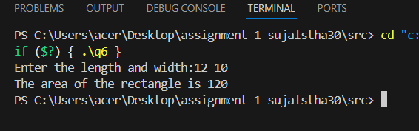
Q7. What is the role of the scanf() function in C? Provide an example of its usage.
The scanf() function in C is the most common way to get an input from the user. If print() function is the program talking to the user, scanf() function is the program listening. It read formatted input from the user. It reads input from the user based on format specifiers (like %d, %f, %c). The syntax of scanf() is scanf(“format string”, &variable1, &variable2, …);
For example:
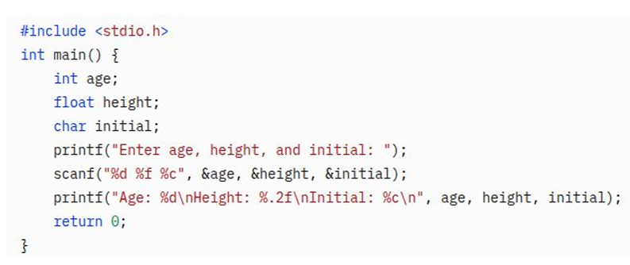
Q8. Write a C program to convert temperature from Celsius to Fahrenheit. Prompt the user for a temperature in Celsius and display the equivalent temperature in Fahrenheit. (Formula: fahrenheit = (celsius * 9 / 5) + 32)
#include <stdio.h>
int main(){
float celsius, fahrenheit;
printf("Enter the temperature:");
scanf("%f",&celsius);
fahrenheit=(celsius*9/5)+32;
printf("The fahrenheit is %.2f",fahrenheit);
return 0;
}
Output:
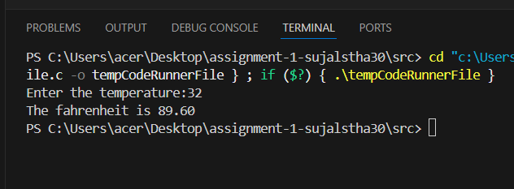
Q9. Input a number representing days and print the equivalent number of weeks and days. (Example: 10 days = 1 week and 3 days)
#include <stdio.h>
int main(){
int num;
printf("Enter a number:");
scanf("%d",&num);

int week, remaining_days;

week = num / 7;
remaining_days = num % 7;
printf("%d week %d days",week,remaining_days);
return 0;
}
Output:
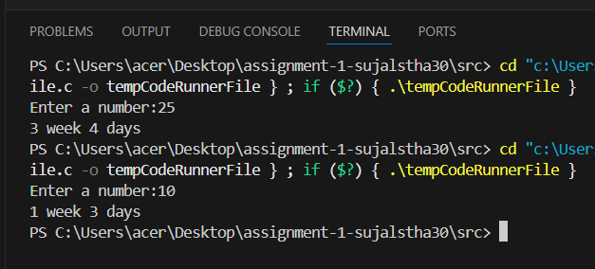
Q10. Write a C program to swap the values of two variables using a temporary variable.
#include <stdio.h>
int main(){
int a,b,temp;
printf("enter two numbers:");
scanf("%d %d",&a,&b);
printf("The value of a before swapping is %d and b is %d\n",a,b);
temp=a;
a=b;
b=temp;
printf("The value of a after swapping is %d and b is %d\n",a,b);
return 0;
}
Output:
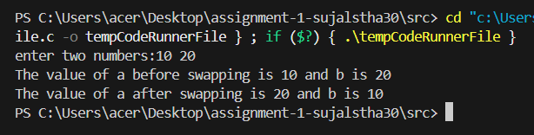
Q11. Write a C expression that performs the following operations in a single line: increment a variable by 1, multiply it by 3, and subtract 10.

#include <stdio.h>
int main(){
int a;
int result;
printf("Enter a number:");
scanf("%d",&a);
result=(a++,a*3-10);
printf("The result is %d\n",result);
return 0;
}
Output:
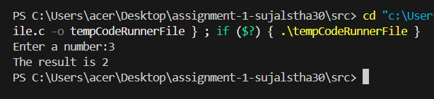
Q12. Given three variables a, b, and c, write an expression that checks if a is greater than b and c is not equal to 0.
#include <Stdio.h>
int main(){
int a,b,c;
int result;
printf("Enter three numbers:");
scanf("%d %d %d",&a,&b,&c);
result=(a>b)&&(c!=0);
printf("The result is %d",result);
return 0;
}
Output:
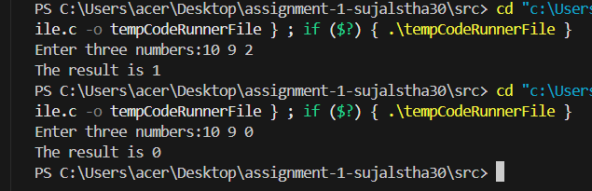
Q13. Write a C expression that evaluates whether a number is divisible by both 2 and 3 (without using the modulus operator).
#include <stdio.h>
int main(){
int num;
int result;
printf("Enter a number:");
scanf("%d",&num);
result=(num/2*2 == num) && (num/3*3 == num);
printf("The result is %d\n",result);
return 0;
}
Output:
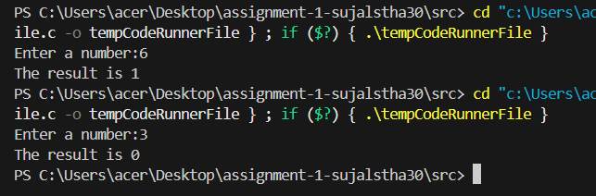
Q14. Create an expression that swaps the values of two variables x and y without using a temporary variable.
#include <stdio.h>
int main(){
int x,y;
printf("Enter two numbers:");
scanf("%d %d",&x,&y);
printf("The value of x before swapping is %d and y is %d\n",x,y);
x=x+y;
y=x-y;
x=x-y;
printf("The value of x after swapping is %d and y is %d\n",x,y);
return 0;
}
Output:
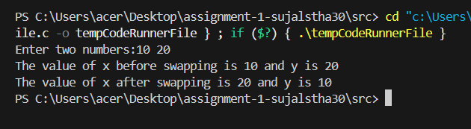
Q15. Write an expression that checks if a number is both positive and even.
#include <stdio.h>
int main(){
int num;
int check;
printf("Enter a number:");
scanf("%d",&num);
check=(num>0)&&(num%2==0);
printf("The result is %d\n",check);
return 0;
}
Output:
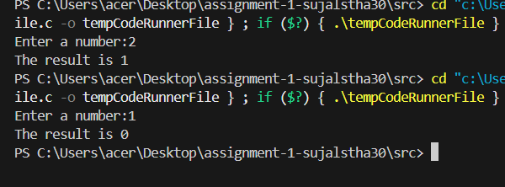
Q16. Given two variables x and y, write an expression that calculates the average of their values.
#include <stdio.h>
int main (){
int x,y;
int average;
printf("Enter two variables:");
scanf("%d %d",&x,&y);
average=(x+y)/2;
printf("The average between the two variables is %d\n",average);
return 0;
}
Output:
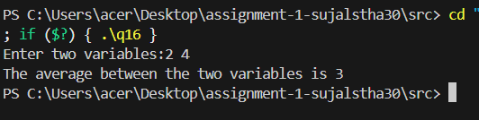
Q17. Create an expression that checks if a given character is an uppercase letter.
#include <stdio.h>
int main(){
char c;
int result;
printf("Enter a character:");
scanf("%c",&c);
result=(c>='A')&&(c<='Z');
printf("The result is %d",result);
return 0;
}
Output:
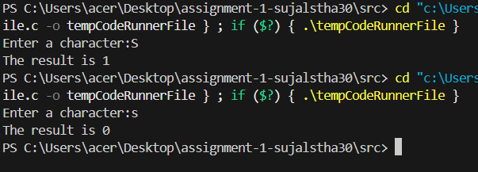
Q18. Write a C expression that calculates the sum of the squares of three different numbers.
#include <stdio.h>
int main(){
int a,b,c;
int sum;
printf("Ente three different numbers:");
scanf("%d %d %d",&a,&b,&c);
sum=(a*a)+(b*b)+(c*c);
printf("The sum of the squares of three different numbers is %d",sum);
return 0;
}
Output:
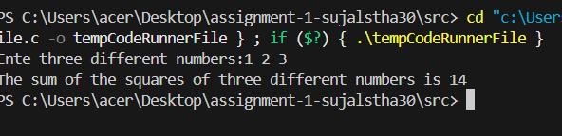
Q19. Given three variables a, b, and c, write an expression that checks if a is equal to b and b is not equal to c.
#include <stdio.h>
int main(){
int a,b,c;
int result;
printf("Enter three variables:");
scanf("%d %d %d",&a,&b,&c);
result=(a==b)&&(b!=c);
printf("The result is %d",result);
return 0;
}
Output:
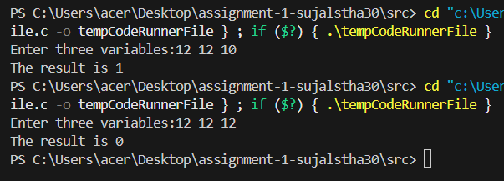
Q20. Write an expression that checks if a number is a multiple of either 3 or 5.
#include <stdio.h>
int main(){
int num;
int result;
printf("Enter a number:");
scanf("%d",&num);
result=(num%3==0)||(num%5==0);
printf("The result is %d",result);
return 0;
}
Output:
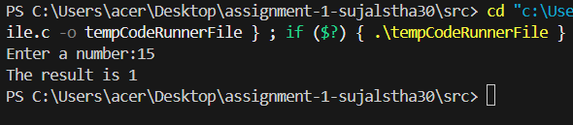
Q21. Create an expression that swaps the values of three variables x, y, and z in a cyclic order (i.e., x becomes y, y becomes z, and z becomes x).
#include <stdio.h>
int main(){
int x,y,z;
int temp;
printf("Enter the value of three variables:");
scanf("%d %d %d",&x,&y,&z);
printf("The value of x before swapping is %d, y is %d and z is %d\n",x,y,z);
temp=x;
x=y;
y=z;
z=temp;
printf("The value of x after swapping is %d, y is %d and z is %d\n",x,y,z);
return 0;
}
Output:
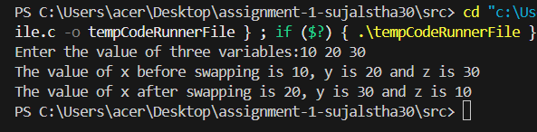
Q22. Write a C expression that calculates the square root of the sum of two numbers, rounded to the nearest integer.
#include <stdio.h>
#include <math.h>
int main(){
int a,b;
int sum;
printf("Enter two numbers:");
scanf("%d %d",&a,&b);
sum=round(sqrt(a)+sqrt(b));
printf("The sum of is %d\n",sum);
return 0;
}

Output:
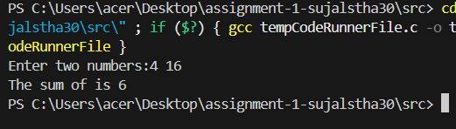
Q23. Given a variable num, write an expression that checks if it is a power of 2.
#include <stdio.h>
int main(){
int num;
int result;
printf("Enter a number:");
scanf("%d",&num);
result=!(num&(num-1));
printf("The result is %d\n",result);
return 0;
}
Output:
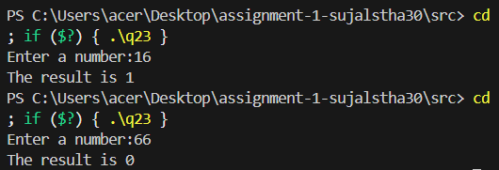
Q24. Create an expression that checks if a given number is a perfect square.
#include <stdio.h>
#include <math.h>
int main(){
int num;
int result;
printf("Enter a number:");
scanf("%d",&num);
result=(sqrt(num)*sqrt(num)==num);
printf("The result is %d\n",result);
return 0;
}
Output:
